**Brief report of result analysis of Kyoto Ecosystem Services project**

Kang

**Abbreviation**

ES – ecosystem service

**General description: not shown here**

**Structure analysis: unfinished**

DBH distribution across land use types – unfinished

**Category of ES and ES values:**

The total value of a tree is composed of structure value (補償額), fixed ES value (in this case, carbon storage value, which is the consequence of carbon sequestration), and annual “added ES values”. The latter, annual added ES values include 3 classes, ordered by the impact of scale: global scale – carbon sequestration value; regional scale – air pollutants removal values, including NO2 removal value, O3 removal value, PM 2.5 removal value, SO removal value (and CO removal value, though it is not accounted in valuation process); local scale – avoided runoff value.

The comparison of the values – mean and sd by plots:

|  |  |  |
| --- | --- | --- |
| Value class | mean | sd |
| carbon_storage_value (?) | 2.6 | 5.2 |
| es_value | 20.9 | 35.9 |
| total_value | 343517.8 | 578318.7 |

**Total ecosystem service values across land use types: unfinished**

I am thinking about to add ES value of plots for the analysis. Since the number of pots of each land use types were stratified by the area of land use types, the sample certainly represent the overall population. While on the other hand, the sum of ES value of all the plots of a certain land use type doesn’t show the information of the ES of that land use of the whole city at all, it can be only applied for the comparison with the sum of other land use type. Therefore, a better practice is to use the extrapolated total ES value of the land use types rather than the sum of ES of the sample plots.

**Proportions of different annual ES values across land use types**

PM 2.5 removal value account for about half of the total value across all land use types, followed by O3 removal, carbon sequestration, and avoided runoff value. While NO2 removal and SO2 removal values only account for a small fraction of the total annual ES value.

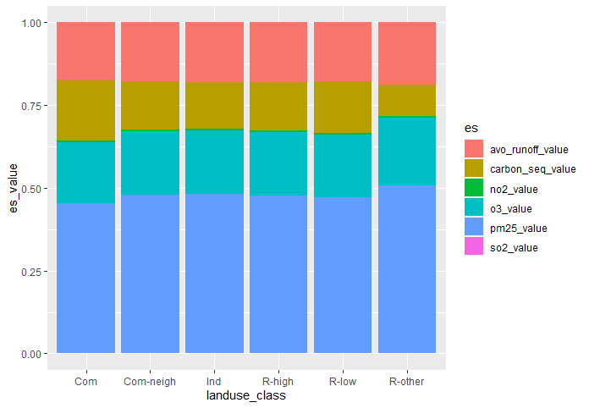

It should be noted that, though ES valuation allows us to compare the value across ES, while ES value varies with valuation method (and mostly, the method applied in i-Tree is replacement cost), users should compare the physical amount of different ES – as shown below.

**Plot-based annual ES across land use types: no significant difference**

Generally non-parameter statistical analysis is applied when the assumption of normal-distribution and homogeneity of variance of data is not satisfied. While this point of statistical analysis is still under debate. Thus, I applied both parameter (ANOVA) and non-parameter (Kruskal test) method to compare the ESs across land use types.

* The results of ANOVA: no significant difference shows for any group of tests (oh, bad new!). The ANOVA p-values are shown in the plot below, as well as the mean values and 95% confidence intervals:

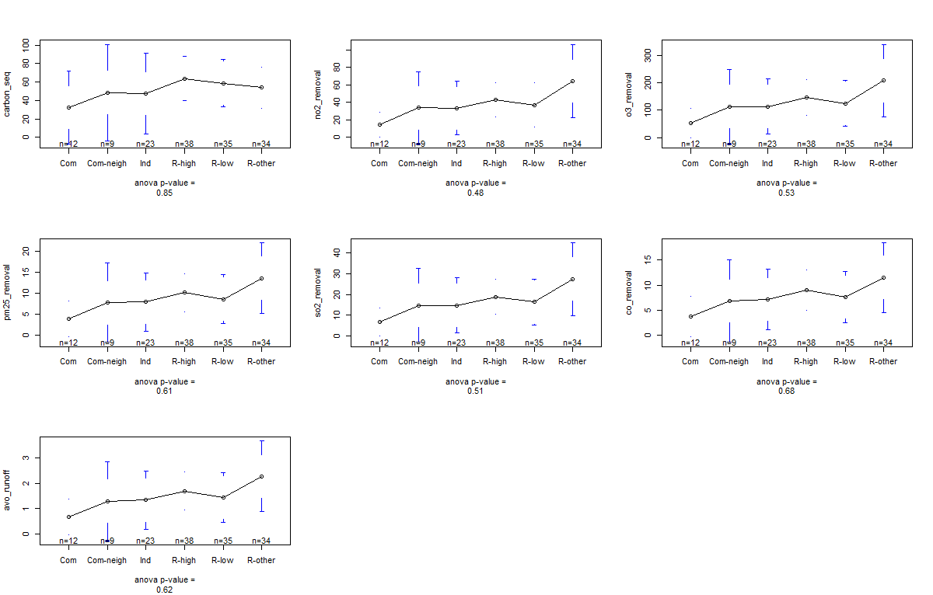

* The results of Kruskal test: no significant difference shows for any group of tests either (oh, really bad news!). The p-values are shown in the plot below, as well as the quantile in the box plots:

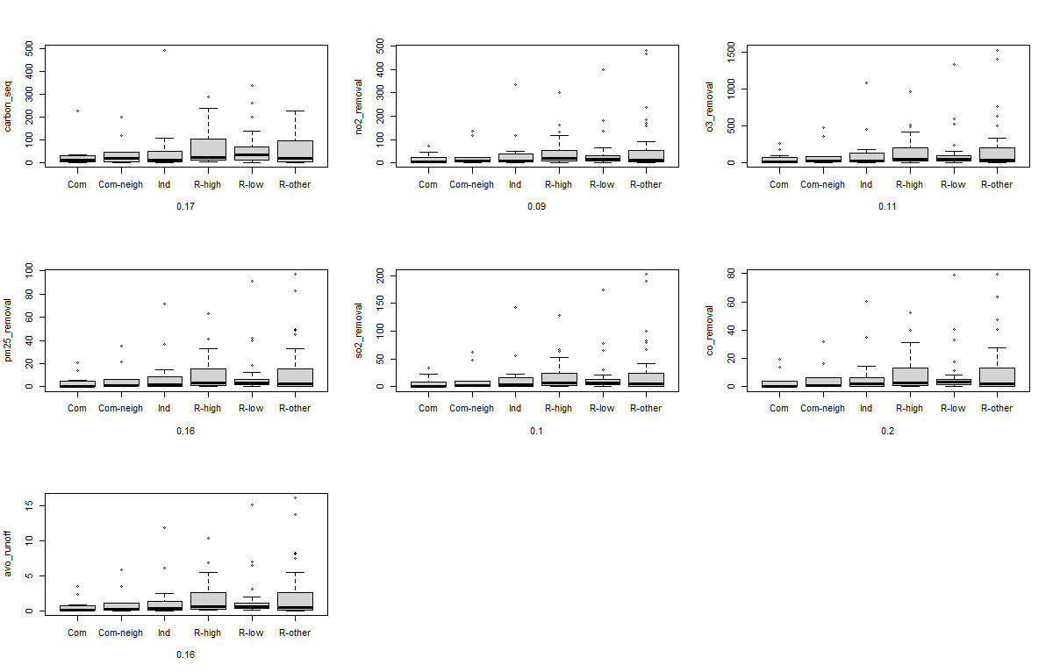

**Individual-based species-specific annual ES across land use types**

Here I only test the species widespread in Kyoto city. The analysis is to compare a sequence of ESs across land use types within same species. The objective is to test the contribution of certain species to total ES (or performance/statement of trees of same species) in different land use types. Also, I tried both parameter and non-parameter analysis here, but only the results of parameter method with significant p-value are shown below.

* Different species show different patterns across land use types, e.g., species ACPA shows higher ES in R-other land use, while species NADO shows higher ES in Com-neigh land use type.
* While within the same species, trees show same pattern despite different ES, e.g., for ACPA, the pattern of ESs across land use types are similar for carbon sequestration, pollutant removal, and avoided runoff.
* Post-hoc comparison was also applied, the differences are mainly resulted from the differences between residential areas and industrial area.

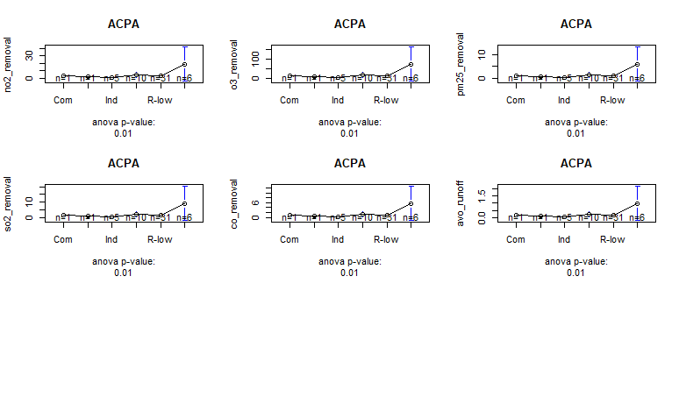

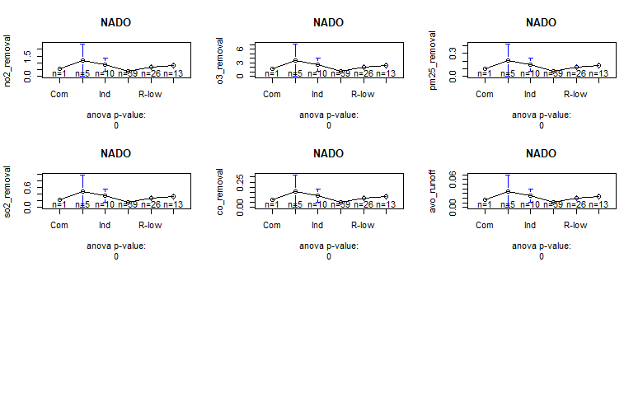

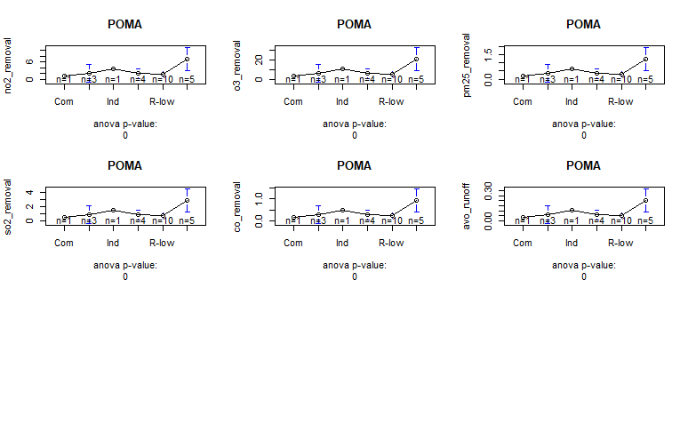

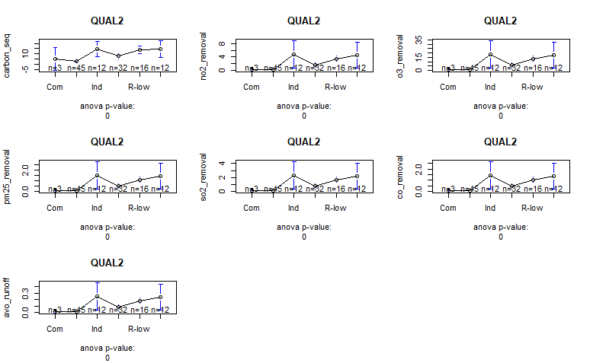

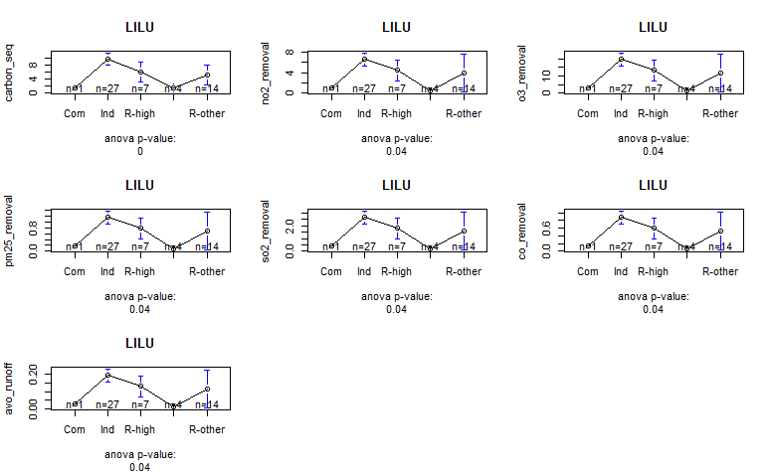

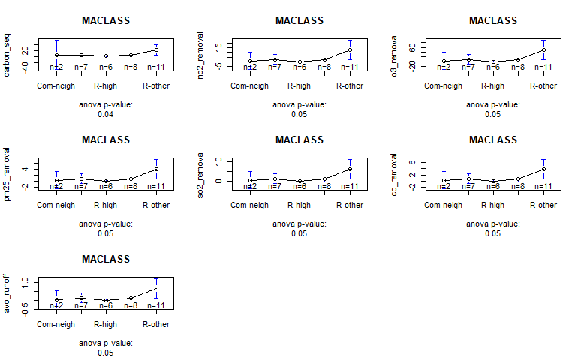

**Cost-benefit balance analysis: unfinished**

**Analysis of structure and ES across land cover: unfinished**

Land use type and land cover are different dimensions of land classification while of different scales. As a more “localized” factor, field land cover (e.g., vacant, cemetery, golf course) may have a larger impact on the pattern of ES.